COS80022 – Software Quality and Testing

Test Report for Lab 4

Student Name: Arun Ragavendhar Arunachalam Palaniyappan
Student ID: 104837257
Student email: 104837257@student.swin.edu.au
Submission date: 21/03/2024

- Test Cases (1st Round)

Table 1
# | Input Data | Expected Result
TC1 | 3,4,5 | “scalene triangle”
TC2 | 7,7,7 | “equilateral triangle”
TC3 | 12,14,30 | “scalene triangle”
TC4 | 2,2,10 | “isoscelos triangle”
TC4 | 5,-3,5 | “isocelos triangle”
TC5 | 8,0,0 | “isosceles traingle”
TC6 | 0,0,0 | “equilateral traingle”

The Initial test cases only satisfy the basic criteria /conditions of the Program and give wrong/impossible outputs as it does not check for necessary requirements/validations.

However, an ideal fully functional program must be able to check more conditions like input must a positive number, boundary conditions should be satisfied to give correct output, etc.

Hence the whole list of ideal test cases was created from the appendix of questions given and the corresponding code was developed and tested for it.

2.Evaluation of Test Cases
Table 2
Question | Answer (Yes or No)
Q1: Do you have a test case that represents a valid scalene triangle? (Note that test cases such as 1, 2, 3 and 2, 5, 10 do not warrant a “yes” answer because there does not exist a triangle having these dimensions.) | Yes
Q2: Do you have a test case that represents a valid equilateral triangle? | Yes
Q3: Do you have a test case that represents a valid isosceles triangle? (Note that a test case representing 2, 2, 4 would not count because it is not a valid triangle.) | Yes
Q4: Do you have test cases in category 3 such that you have tried the permutations of two equal sides (such as, 3, 3, 4; 3, 4, 3; and 4, 3, 3)? | Yes
Q5: Do you have a test case in which one side has a zero value? | Yes
Q6: Do you have a test case in which one side has a negative value? | Yes
Q7: Do you have a test case with three integers greater than zero such that the sum of two of the numbers is equal to the third? (That is, if the program said that 1, 2, 3 represents a scalene triangle, it would contain a bug.) | Yes
Q8: Do you have test cases in category 7 such that you have tried the permutations where the length of one side is equal to the sum of the lengths of the other two sides (for example, 1, 2, 3; 1, 3, 2; and 3, 1, 2)? | Yes
Q9: Do you have a test case with three integers greater than zero such that the sum of two of the numbers is less than the third (such as 1, 2, 4 or 12,15,30)? | Yes
Q10: Do you have at least three test cases in category 9 such that you have tried the permutations where the sum of two of the numbers is less than the third (for example, 1, 2, 4; 1, 4, 2; and 4, 1, 2)? | Yes
Q11: Do you have a test case in which all sides are zero (0, 0, 0)? | Yes
Q12: Do you have at least one test case specifying non-integer values (such as 2.5, 3.5, 5.5)? | Yes
Q13: Do you have at least one test case specifying the wrong number of values (two rather than three integers, for example)? | Yes
Q14: For each test case did you specify the expected output from the program in addition to the input values? | Yes

- Test Cases (2nd Round)

Table 3
# | Input Data | Expected Result (Oracle) | Actual Output(log)
TC1 | 3,4,5 | “scalene Triangle” | “scalene Triangle”
TC2 | 7,7,7 | “equilateral triangle” | “equilateral triangle”
TC3 | 12,14,30 | “invalid entry-the sides do not form a triangle” | “invalid entry-the sides do not form a triangle”
TC4 | 14,12,30 | “invalid entry-the sides do not form a triangle” | “invalid entry-the sides do not form a triangle”
TC5 | 30,12,14 | “invalid entry-the sides do not form a triangle” | “invalid entry-the sides do not form a triangle”
TC6 | 2,2,10 | “invalid entry-the sides do not form a triangle” | “invalid entry-the sides do not form a triangle”
TC7 | 5,-3,5 | “invalid entry-enter a positive integer” | “invalid entry-enter a positive integer”
TC8 | 8,0,0 | “invalid entry-enter a positive integer” | “invalid entry-enter a positive integer”
TC9 | 0,0,0 | “invalid entry-enter a positive integer” | “invalid entry-enter a positive integer”
TC10 | 9,9,15 | “isosceles triangle” | “isosceles triangle”
TC11 | 9,15,9 | “isocelos triangle” | “isosceles triangle”
TC12 | 15,9,9 | “isocelos triangle” | “isosceles triangle”
TC13 | 3,5,0 | “invalid entry-enter a positive integer” | “invalid entry-enter a positive integer”
TC14 | 3,4,7 | “invalid entry-the sides do not form a triangle” | “invalid entry-the sides do not form a triangle”
TC15 | 7,3,4 | “invalid entry-the sides do not form a triangle” | “invalid entry-the sides do not form a triangle”
TC16 | 7,4,3 | “invalid entry-the sides do not form a triangle” | “invalid entry-the sides do not form a triangle”
TC17 | 6.2,4.4,8.1 | “a=int(input())  ^^^^^^^^^^^^  ValueError: invalid literal for int() with base 10: '6.2,4,4,8.1’ | a=int(input())  ^^^^^^^^^^^^  ValueError: invalid literal for int() with base 10: ''6.2,4,4,8.1’
TC18 | 4,8 | c=int(input())  ^^^^^^^^^^^^  ValueError: invalid literal for int() with base 10: ' ' | c=int(input())  ^^^^^^^^^^^^  ValueError: invalid literal for int() with base 10: ' '

Python source code of the program:

print("enter the value of the 3 sides:")
a=int(input())
b=int(input())
c=int(input())

if(a>0 and b>0 and c>0):

if((a+b>c) and (b+c>a) and (c+a>b)):

if((a!=b) and (b!=c) and (c!=a)):
print("scalene triangle")

elif (((a==b) and (a!=c)) or ((a==c) and (a!=b)) or ((b==c) and (b!=a))):
print("isoscelos triangle")

elif(a==b==c):
print("equilateral triangle")

else:
print("invalid entry-the sides do not form a triangle")

else:
print("invalid entry-enter a positive integer")

Test case Outputs:

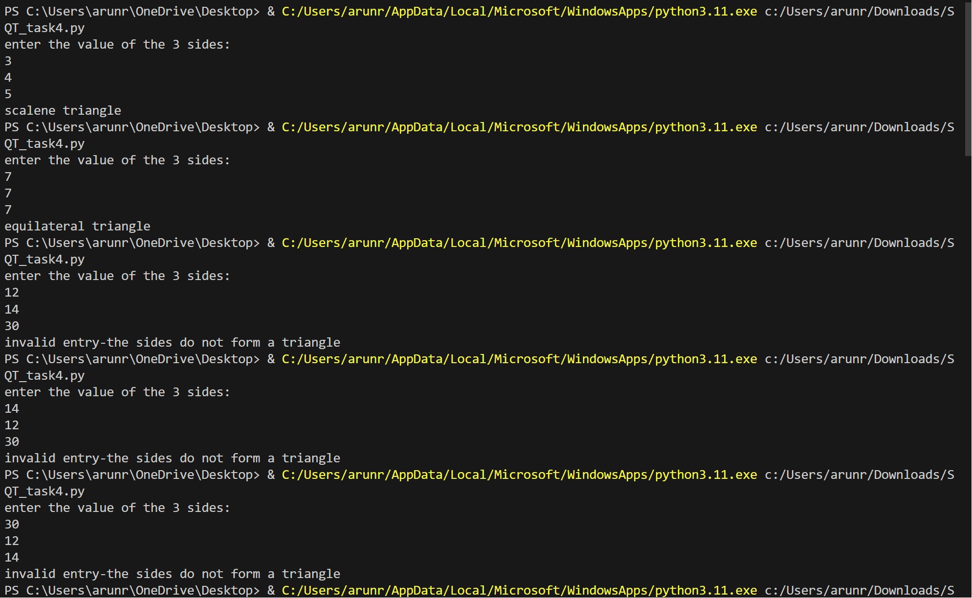

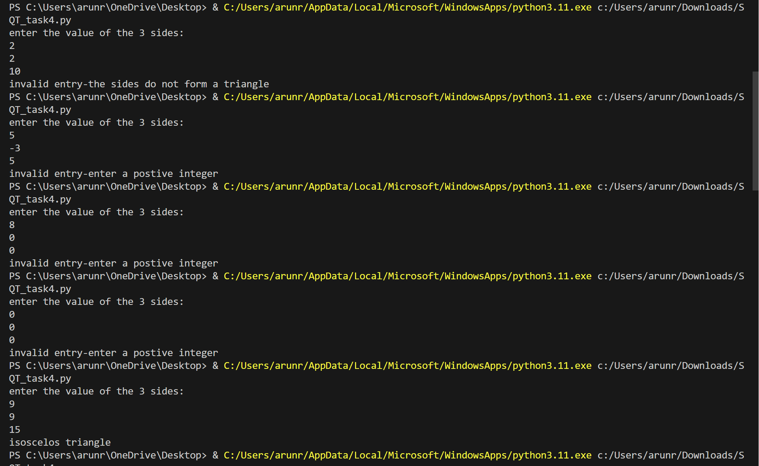

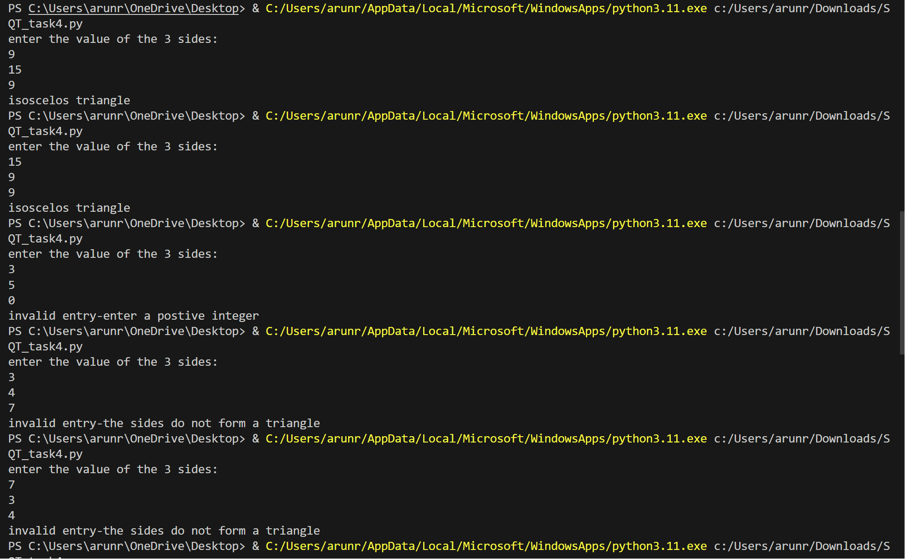

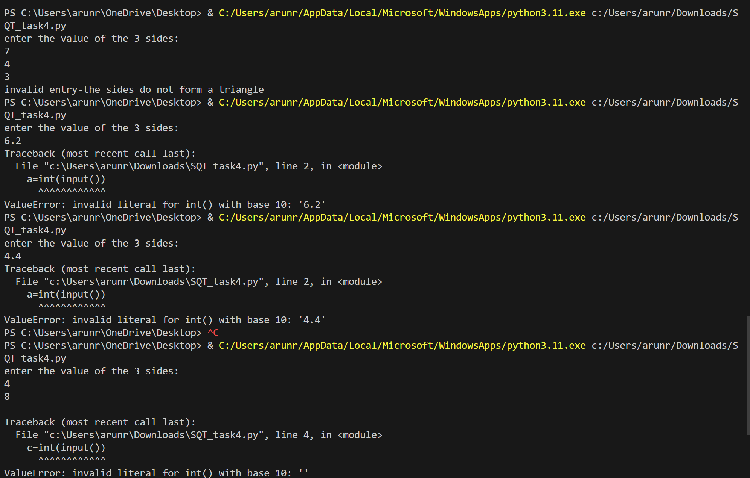

The Actual result outputs are exactly same as the expected results. Hence the program’s software quality and testing has been successful for all designed test cases.

